WORLD AIDS DAY CELEBRATIONS REPORT
DATE; 1ST DEC 2018
VENEUE; KARANDA PRIMARY SCHOOL NYANDO SUB COUNTY:
GUEST OF HONOUR; First lady Kisumu County; Dorothy Nyong’o
FACES program was led by;
- The Director Dr. Francesca Odhiambo
- TA SSD; Samuel Ndolo Apuot
- Sub-county coordinators; Eric Juma and Cillilus Ogolla
- Sub-County technical teams
- Service providers from various facilities supported by FACES.
The occasion was attended by large numbers of FACES staff with Kisumu adolescents dressed in FACES branded T-shirts stealing the attention and admiration of many people.
Pre-world AIDS day activities
The preparations started with sub- County planning meetings which was chaired by the MOH Nyando with implementing partners within the sub-county present and involved in the planning process.
FACES as a program was assigned to take lead in the following activities;
- Conduct a three day door to door testing within Tura location involving ten HTS counsellors.
- Support mobilizations for meaningful attendance at the occasion within the sub- County by involving twenty CHVS for three days with each CHV targeted to bring at least 10 people from the village.
- Prepare at least 3 testimonies for PLWHA within the sub-county from the FACES supported sites.
- Organize at least three special speeches and two plays from adolescents within the sub –county.
- Facilitate SCHMT with refreshments on the celebration day.

Mobilization.
- A two day mobilizations for the general populations was conducted by the FACES program through PA system on a vehicle which crisscrossed the entire Nyando region and it is through this effort that resulted into a large number of people attending this important occasion.
- A total of forty seven boda boda operators mobilized by FACES led the procession to the meeting venue starting from Ahero outskirts to Karanda playing ground
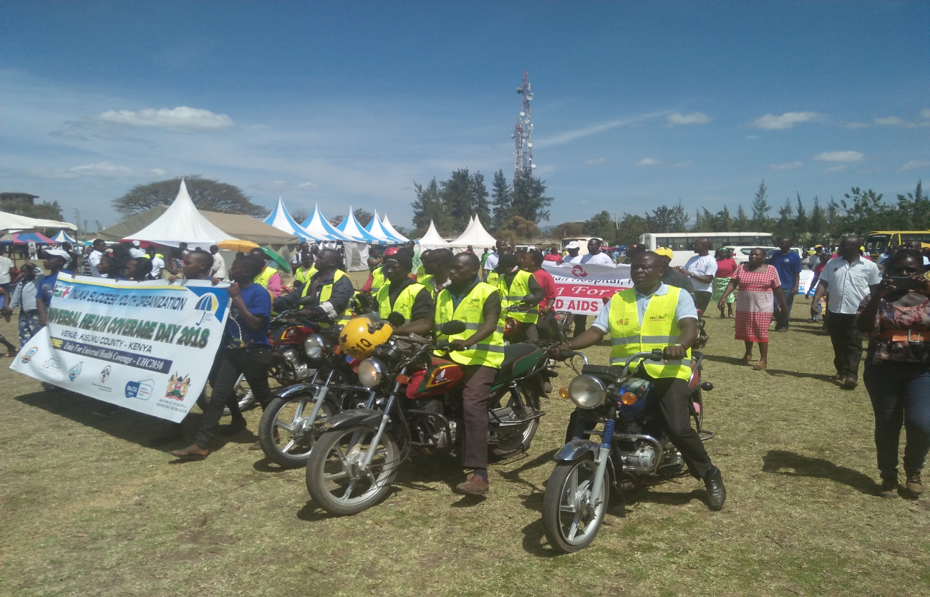
Build up activities
- FACES program had a tent which was showcasing and providing services offered by the program
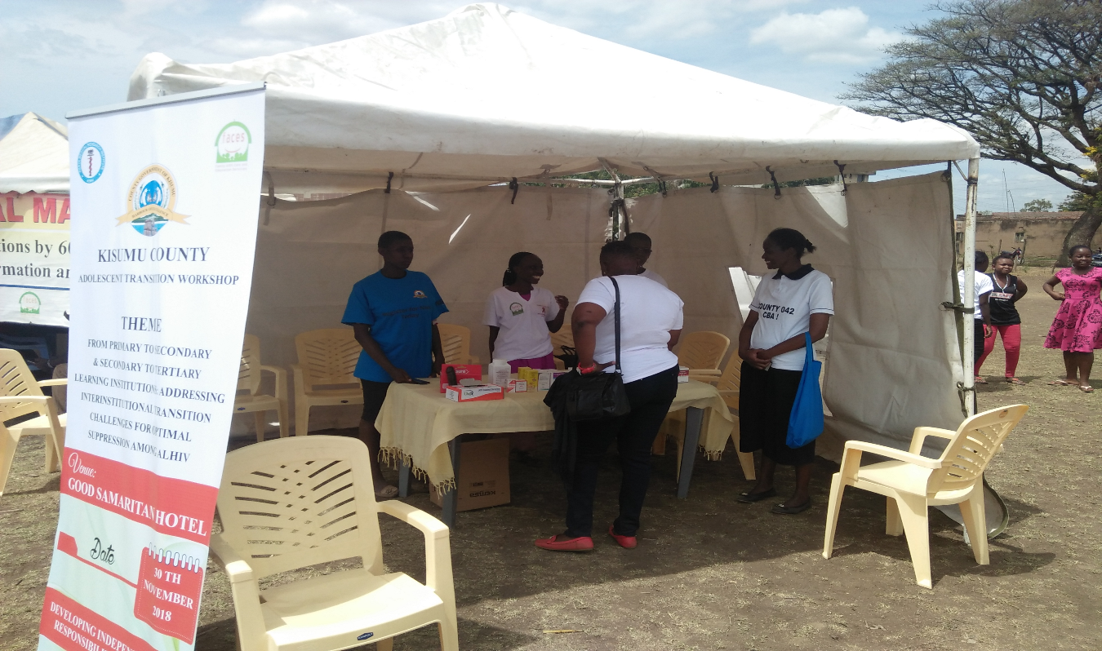
- We had a tent for HTS services with mobilizers stationed strategically identifying and leading clients to the tent for counselling and testing. With 7 HTS counselors present (1 mobilizing while 6 testing), we managed to conduct counseling and testing to 161 clients and linked them to other appropriate services that were necessary. We didn’t identify a positive HIV positive results at this testing point.
- The program also managed to mobilize and market VMMC services to the community and those in attendance as well, where 4 clients opted to benefit from these services. These clients where linked to our Ahero VMMC Centre adjacent to the venue where VMMC services were being conducted.
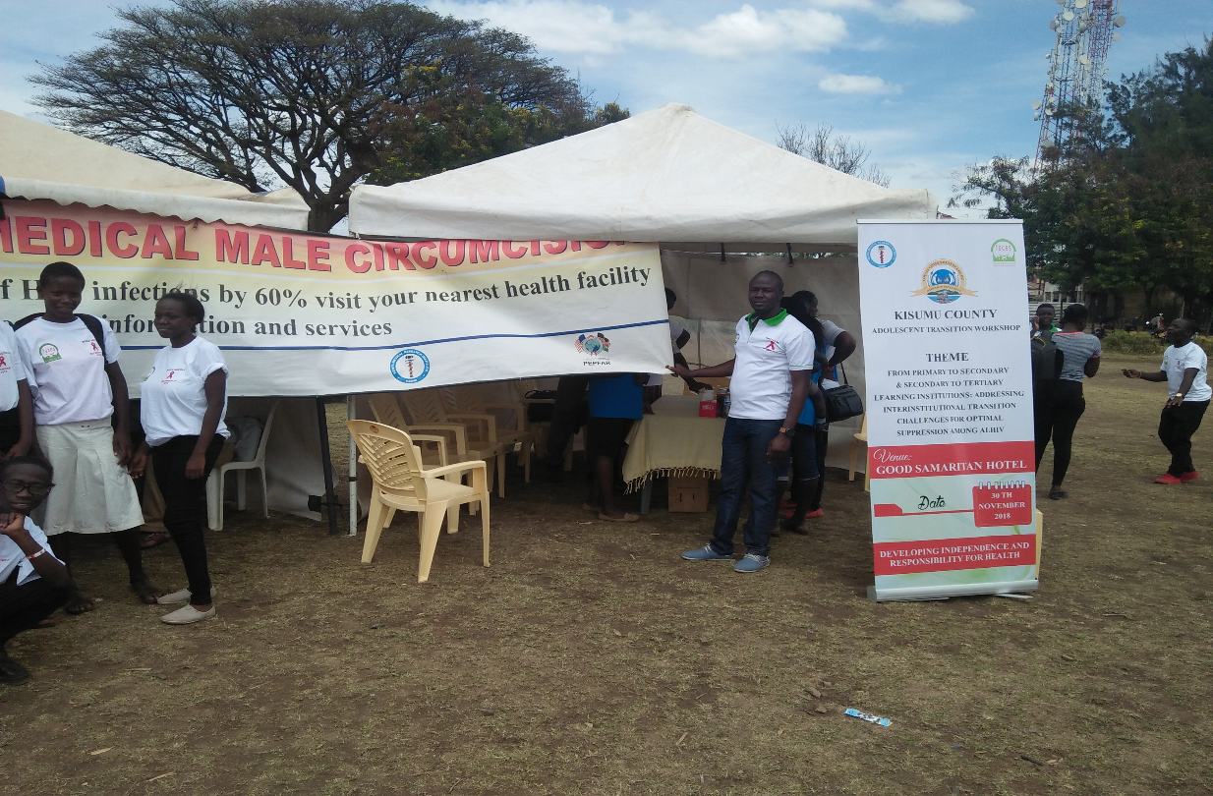
- A cross sectional of Clinical services provided by FACES were also showcased to the public while encouraging and directing the interested clients where to seek services starting with HTS services.
- A vibrant Kisumu adolescent was able to give her testimony before the Kisumu County first lady. The testimony appreciated the support from FACES that has kept adolescents to continue having hope through the quality of services being provided to them which has enabled them excel even in their studies in school.
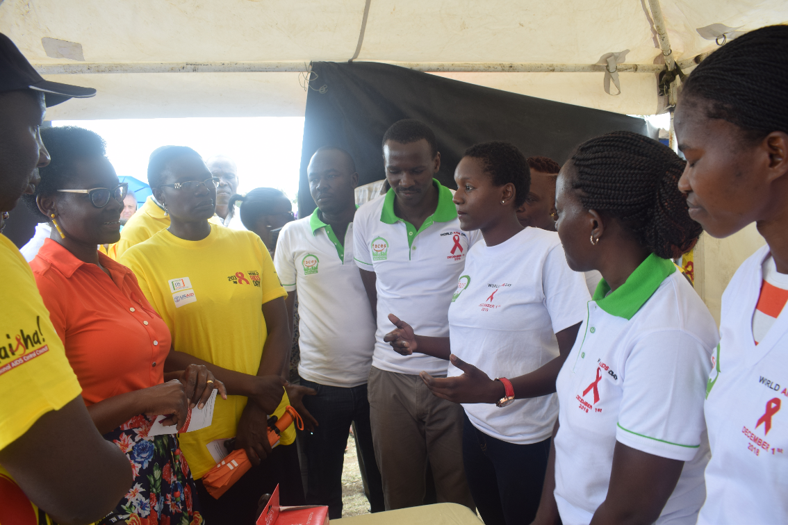
- A hero adolescents were also able to make a play on HIV care support which moved the crowd.
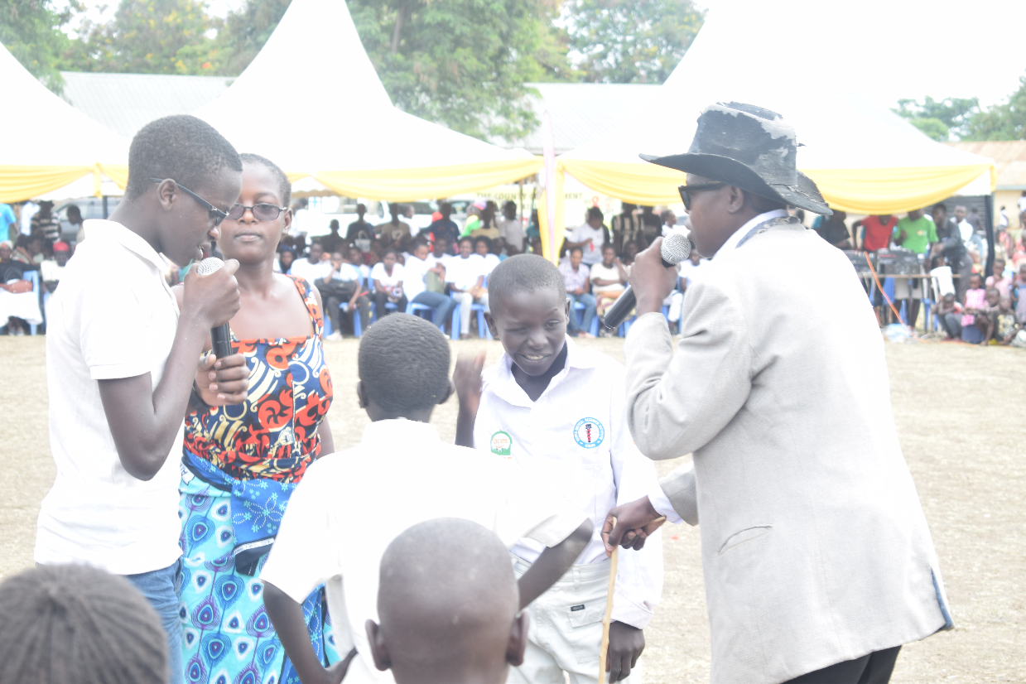
Compiled by Eric Juma

